

Semester 1 Examination 2010

Question/Answer Booklet

MATHEMATICS 3C/3D

Section Two

(Calculator Assumed) Student Number

Name
Teacher ___________________________________

Time allowed for this section

Reading time before commencing work: 10 minutes
Working time for paper: 100 minutes

Material required/recommended for this section

To be provided by the supervisor
Question/answer booklet for Section Two.
Formula sheet.

To be provided by the candidate
Standard items: pens, pencils, pencil sharpener, highlighter, eraser, ruler.
Special items: drawing instruments, templates, notes on up to two unfolded sheets of A4 paper, and up to three calculators, CAS, graphic or scientific, which satisfy the conditions set by the Curriculum Council for this course.

Important note to candidates
No other items may be taken into the examination room. It is your responsibility to ensure that you do not have any unauthorised notes or other items of a non-personal nature in the examination room. If you have any unauthorised material with you, hand it to the supervisor before reading any further.

Structure of this examination

 | Number of questions | Working time (minutes) | Marks available
Section One  Calculator Free | 7 | 50 | 40
This Section (Section 2)  Calculator Assumed | 12 | 100 | 80
Total marks |  |  | 120

Instructions to candidates

- The rules for the conduct of WACE external examinations are detailed in the booklet WACE Examinations Handbook. Sitting this examination implies that you agree to abide by these rules.

- Answer the questions in the spaces provided.

- Spare answer pages are provided at the end of this booklet. If you need to use them, indicate in the original answer space where the answer is continued i.e. give the page number.

- Show all working clearly. Any question, or part question, worth more than 2 marks requires valid working or justification to receive full marks. If you repeat an answer to any question, ensure that you cancel the answer you do not wish to have marked.

Section Two: Calculator-assumed (80 Marks)
This section has twelve (12) questions. Answer all questions. Write your answers in the space provided.
Spare pages are included at the end of this booklet. They can be used for planning your responses and/or as additional space if required to continue an answer.
  - Planning: If you use the spare pages for planning, indicate this clearly at the top of the page.
  - Continuing an answer: If you need to use the space to continue an answer, indicate in the original answer space where the answer is continued, i.e. give the page number. Fill in the number of the question(s) that you are continuing to answer at the top of the page.

Suggested working time for this section is 100 minutes.

Question 8 (8 marks)
A basketball training squad consists of 4 guards, 2 centres and 3 forwards. A team of 5 is to be chosen to start the game.
In how many ways can this starting team be chosen if:
(a) there are no restrictions? (1 mark)

(b) the team must consist of 2 guards, 1 centre and 2 forwards? (2 marks)

(c) the team includes at most 2 centres? (3 marks)

Julie is a centre player and is chosen in the team. If the other players are selected at random, what is the probability that:
(d) Julie is the only centre in the team? (2 marks)
Question 9 (5 marks)
(a) The composite function f(g(x)) = e^{2x − 6}. Determine two different pairs of equations for functions f(x) and g(x). (2 marks)

(b) If f(x) = 3x² − 2 and h(x) = 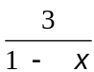 find h(f(x). (1 mark)

(c) A composite function is defined by the equation h(f(x)) = 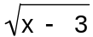 − 4. Determine the domain and range of this function for x real. (2 marks)

Question 10 (5 marks)
In the first five seconds of inflation, the relationship between the radius (r cm) and time (t sec) of a spherical party balloon are related by the formula
r = −t(t − 10)
(a) Show that the relationship between volume (V cm³) and time is given by V = 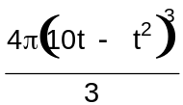
(1 mark)

(b) Determine the exact volume of the balloon 3 seconds after first being inflated. (1 mark)

(c) Determine the approximate change in volume as t increases from 3 to 3.01 sec. (3 marks)

Question 11 (5 marks)

Consider the function f(x) = x³ + ax² + 2x + b where a and b are constants

(a) Find an expression for the gradient of the curve (1 mark)

(b) Given that the tangents at A(0, b) and B(2, 5) are parallel, find the value of a and b.
(4 marks)

Question 12 (5 marks)
A mathematics teacher, in conversation with a colleague explained that her Year 10 class of students could be classified as
Well behaved (Group A consisting of 15 students)
Moderately behaved (Group B consisting of 10 students)
Poorly behaved (Group C consisting of 5 students)
She also mentioned that when there is a full moon on any particular lunar cycle the probability that a student will misbehave one or more times is 0.05, 0.15 and 0.3 for a randomly selected student from Group A, B and C respectively.
(a) What is the probability that a randomly selected student will misbehave at least once within a lunar cycle?
(2 marks)

(b) If a randomly selected student had misbehaved at least once during a lunar cycle, what is the probability the student was from Group C? (3 marks)

Question 13 (8 marks)
In a packet of multi-coloured Statice seeds (a flower) only one in fifteen seeds will germinate to have a yellow flower.
(a) In a trial 500 seeds germinated.
(i) How many might we expect (mean) to have a yellow flower? (1 mark)

(ii) How many yellow flowered germinated seeds might we expect within two standard deviation of the mean. (2 marks)

(b) Consider a home gardener who has germinated 20 seeds. What is the probability that
(i) exactly two of the 20 seeds will have yellow flowers? (1 mark)

(ii) more than three germinated seeds will have a yellow flower? (1 mark)

(c) How many germinated seeds are required if a home gardener wants to be at least 95% confident that at least one germinated seed will have a yellow flower? (3 marks)

Question 14 (8 marks)
On the axes below draw the curves 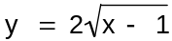 and y = x³ − x² − 5x − 4.
 (3 marks)
(a) Determine any points of inflection. (1 mark)

(b) Explain why there will only be one turning point. (1 mark)

(c) Use calculus techniques to determine where the exact turning points occur. (3 marks)

Question 15 (8 marks)
A function is defined as y = pxe^{qx} where p and q are constants.
(a) Determine 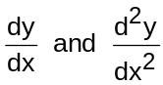. (3 marks)

(b) Using the results found in (a), determine the values for p and q so that y has a maximum of 1 when x = (5 marks)

Question 16 (8 marks)
The makers of a new serum have reported that when injected into damaged cells the serum spread doubles every hour until all damaged cells have been exposed to the serum after 24 hours.
(a) At 9.00am a patient is injected with the serum. At what time, are half of the infected cells expected to be exposed to the serum? Justify your answer. (2 marks)

(b) Medical instruments cannot identify any visible change in the damaged cells when less than 1% of the damaged cells have been exposed to the serum. If the serum was injected into the damaged cells at 9.00am, at what time would medical instruments detect the exposure of the serum on the damaged cells? (6 marks)

Question 17 (8 marks)
A manufacturer produces 100mm metal rods for sale to another firm. Investigations revealed that the rod lengths are normally distributed with a mean of 100.2mm and a variance of 0.16mm.
The receiving firm will only accept a rod if its length is between 99mm and 101mm
(a) What proportion of rods will be accepted by the receiving firm? (1 marks)

(b) If a rod has been accepted by the receiving firm, what is the probability it was less than 100mm? (1 marks)

(c) What is the length exceeded by 95% of all rod lengths produced by the manufacturer?
(2 marks)

To reduce the number of rejected rods the manufacturer wishes to reduce the variability of the lengths.
(d) If 99% of the rods must have a length within 0.5mm of the mean (100.2mm), determine the standard deviation length. (4 marks)

Question 18 (6 marks)
Two competing cyclist are riding with constant speed. At 12 midday cyclist X is 40 metres north of a judge and is riding east at 9m/s, while cyclist Y is 70 metres east of the judge and is riding north at 7m/s.
(a) Show diagrammatically this situation (a scale diagram is not required) (1 mark)

(b) If the distance between the cyclist t seconds later is D metres, show that
D² = 6500 −1820t + 130t² (3 marks)

(c) Determine the time the cyclists are closest together and determine the minimum distance between them. (2 marks)

Question 19 (5 marks)
The cross section of land can be modeled by the equation

H = 0.00003d(d − 30)(d − 50)(100 − d) where H and d are, respectively, the height (in metres) above a fixed horizontal level and the distance (in metres) from a fixed point.

The cross section has been shown in the diagram below.

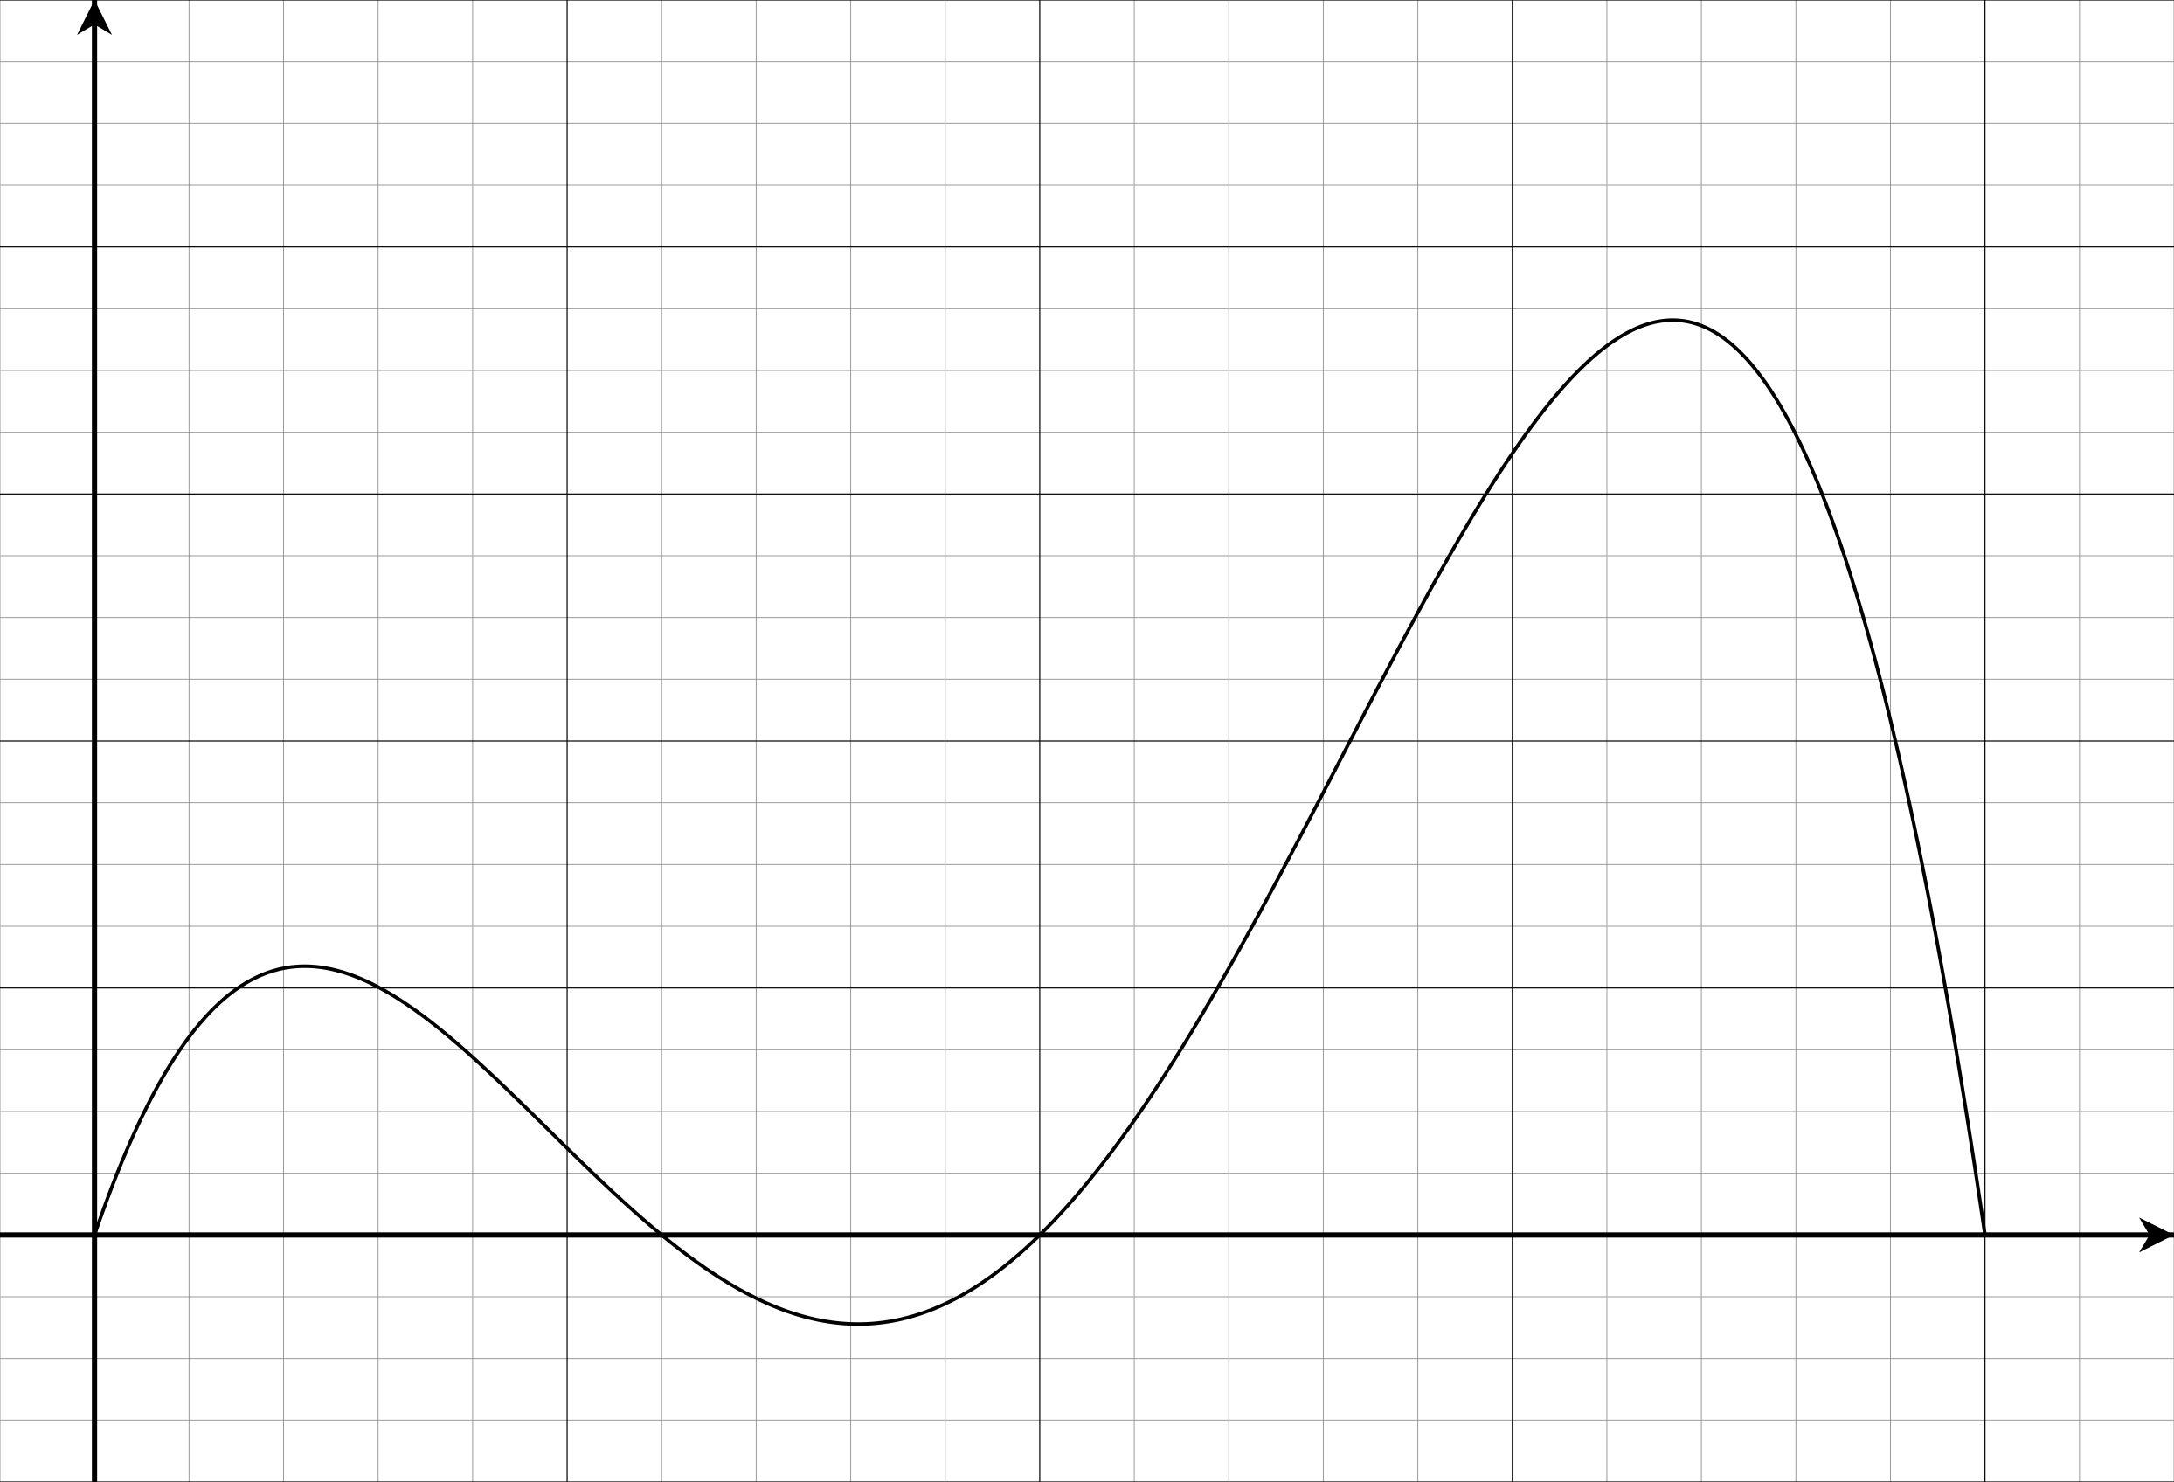

A tunnel, 10m high, will be constructed through the two hills. Show how the cross sectional area of soil removed can be determined using integrals and mensuration (measurement) formula. There is
no need to evaluate your answer. (5 marks)
Additional working space
Additional working space

Question 8 (8 marks)
A basketball training squad consists of 4 guards, 2 centres and 3 forwards. A team of 5 is to be chosen to start the game.
In how many ways can this starting team be chosen if:
(a) there are no restrictions? (1 mark)
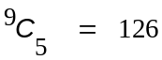 √

(b) the team must consist of 2 guards, 1 centre and 2 forwards? (2 marks)
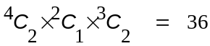 √ √

(c) the team includes at most 2 centres? (3 marks)
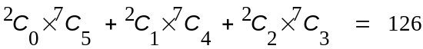 √ √ √

Julie is a centre player and is chosen in the team. If the other players are selected at random, what is the probability that
(d) Julie is the only centre in the team? (2 marks)
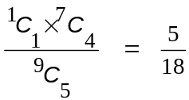 √ √
Question 9 (4 marks)
(a) The composite function f(g(x)) = e^{2x − 6}. Determine two different pairs of equations for functions f(x) and g(x). (2 marks)

f(x) = e^{x} and g(x) = 2x − 6 √

f(x) = e^{2x − 6} and g(x) = x √ (Alternatives possible)

(b) If f(x) = 3x² − 2 and h(x) = find h(f(x). (1 mark)

h(f(x)) = 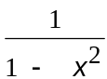 √

(c) A composite function is defined by the equation h(f(x)) = − 4. Determine the domain and range of this function for x real. (2 marks)

Domain x ≥ 3 √ Range y ≥ −4 √
Question 10 (5 marks)
In the first five seconds of inflation, the relationship between the radius (r cm) and time (t sec) of a spherical party balloon are related by the formula
r = −t(t − 10)
(a) Show that the relationship between volume (V cm³) and time is given by V =
r = (10t −t²) and V = 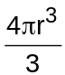 = √ (1 mark)

(b) Determine the exact volume of the balloon 3 seconds after first being inflated. (1 mark)
12348π cm³ √

(c) Determine the approximate change in volume as t increases from 3 to 3.01 sec. (3 marks)
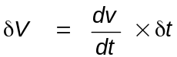
= 4π(10t − t²)²(10 − 2t) × 0.01 (at t = 3) √ √
= 70.56π cm³ √

Question 11 (5 marks)

Consider the function f(x) = x³ + ax² + 2x + b where a and b are constants

(a) Find an expression for the gradient of the curve (1 mark)

f’(x) = 3x² + 2ax + 2 √

(b) Given that the tangents at A(0, b) and B(2, 5) are parallel, find the value of a and b.
(4 marks)
f’(0) = f’(2)
2 = 12 + 4a + 2 √
a = −3 √
f(2) = 5
2³ − 3.2² + 2.2 + b = 5 √
b= 5 √
Question 12 (5 marks)
A mathematics teacher, in conversation with a colleague explained that her Year 10 class of students could be classified as
Well behaved (Group A consisting of 15 students)
Moderately behaved (Group B consisting of 10 students)
Poorly behaved (Group C consisting of 5 students)
She also mentioned that when there is a full moon on any particular lunar cycle the probability that a student will misbehave one or more times is 0.05, 0.15 and 0.3 for a randomly selected student from Group A, B and C respectively.
(a) What is the probability that a randomly selected student will misbehave at least once within a lunar cycle?
A tree diagram would assist. (2 marks)
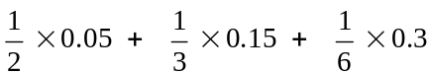 √
= 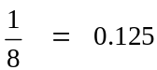 √

(b) If a randomly selected student had misbehaved at least once during a lunar cycle, what is the probability the student was from Group C? (3 marks)

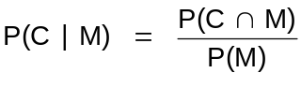 √
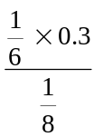 √
= 0.4 √

Question 13 (8 marks)
In a packet of multi-coloured Statice seeds (a flower) only one in fifteen seeds will germinate to have a yellow flower.
(a) In a trial 500 seeds germinated.
(i) How many might we expect (mean) to have a yellow flower? (1 mark)
≈ 33 √
(ii) How many yellow flowered germinated seeds might we expect within two standard deviation of the mean. (2 marks)
2 SD is 0.954499… of 500 √
≈ 477 seeds √

(b) Consider a home gardener who has germinated 20 seeds. What is the probability that
(i) exactly two of the 20 seeds will have yellow flowers? (1 mark)
binomialPDf(2, 20, 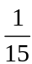) ≈ 0.2439 √

(ii) more than three germinated seeds will have a yellow flower? (1 mark)
binomialCDf(4, 20, 20, ) ≈ 0.0405 √
(c) How many germinated seeds are required if a home gardener wants to be at least 95% confident that at least one germinated seed will have a yellow flower? (4 marks)
p(X ≥ 1) ≥ 0.95 ⇒ P(X = 0) < 0.05 √
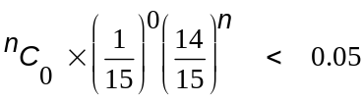 √
n > 43.42 √
Hence 44 germinating seeds are required. √

Question 14 (8 marks)
On the axes below draw the curves and y = x³ − x² − 5x − 4.
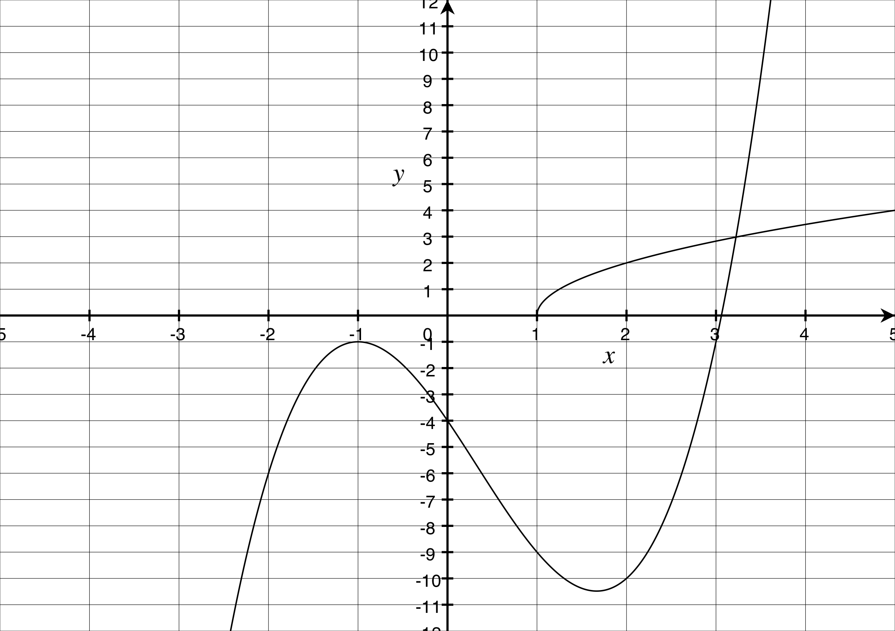 (3 marks)
(a) Determine any points of inflection. (1 mark)
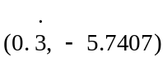 √
(Note: The calculator picks up the end point of the square root function but it is not a point of inflection)
(b) Explain why there will only be one turning point. (1 mark)
As x tends to positive infinity, both functions tend to infinity but the cubic will not have any other turning points to intersect the square root function. √

(c) Use calculus techniques to determine where the exact turning points occur. (3 marks)
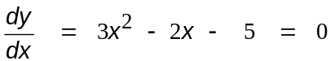 √
(x + 1)(3x − 5) = 0 √
x = −1, √
Question 15 (8 marks)
A function is defined as y = pxe^{qx} where p and q are constants.
(a) Determine . (3 marks)
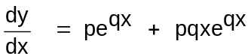 √
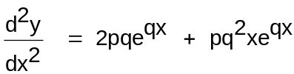 √ √

(b) Using the results found in (a), determine the values for p and q so that y has a maximum of 1 when x = (5 marks)
0.5pe^{0.5q} = 1 √ and pe^{0.5q} + 0.5pqe^{0.5q} = 0 √√
Solving simultaneous equations
p ≈ 5.4366 q = −2 √ √
Question 16 (8 marks)
The makers of a new serum have reported that when injected into damaged cells the serum doubles every hour until all damaged cells have been exposed to the serum after 24 hours.
(a) At 9.00am a patient is injected with the serum. At what time, are half of the infected cells expected to be exposed to the serum? Justify your answer. (2 mark)
If the serum reportedly doubles the number of exposed cells every hour then 23 hours after 9.00am half of them would have been exposed to the serum because all of them would have been exposed to the serum after 24 hours. √
8.00am the following day. √

(b) Medical instruments cannot identify any visible change in the damaged cells when less than 1% of the damaged cells have been exposed to the serum. If the serum was injected into the damaged cells at 9.00am, at what time would medical instruments detect the exposure of the serum on the damaged cells? (6 marks)
The exponential growth function is G =G₀e^{kt}
Because it doubles every hour 2 = e^{k} √
k ≈ 0.6931 √
When 1% of the damaged cells have been exposed to the serum
then 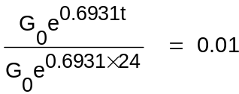 √ √
t ≈ 17.36 hours √
At approximately 2.22 am the following day. √
Question 17 (8 marks)
A manufacturer produces 100mm metal rods for sale to another firm. Investigations revealed that the rod lengths are normally distributed with a mean of 100.2mm and a variance of 0.16mm.
The receiving firm will only accept a rod if its length is between 99mm and 101mm
(a) What proportion of rods will be accepted by the receiving firm? (1 marks)
P(99 < X < 101) ≈ 0.9759 (with the SD at 0.4) √

(b) If a rod has been accepted by the receiving firm, what is the probability it was less than 100mm? (2 marks)
P(X < 100 | 99 < X < 101) = 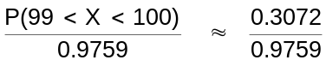 √
≈ 0.3148 √
(c) What is the length exceeded by 95% of all rod lengths produced by the manufacturer?
(2 marks)
P(X > k) = 0.95
k ≈ 99.5421 √ √
To reduce the number of rejected rods the manufacturer wishes to reduce the variability of the lengths.
(d) If 99% of the rods must have a length within 0.5mm of the mean (100.2mm), determine the standard deviation length. (3 marks)
P(−∞ < Z < k) = 0.995 √
k ≈ 2.575829 √
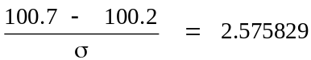
σ ≈ 0.1941 √

Question 18 (6 marks)
Two competing cyclist are riding with constant speed. At 12 midday cyclist X is 40 metres north of a judge and is riding east at 9m/s, while cyclist Y is 70 metres east of the judge and is riding north at 7m/s.
(a) Show diagrammatically this situation (a scale diagram is not required) (1 mark)
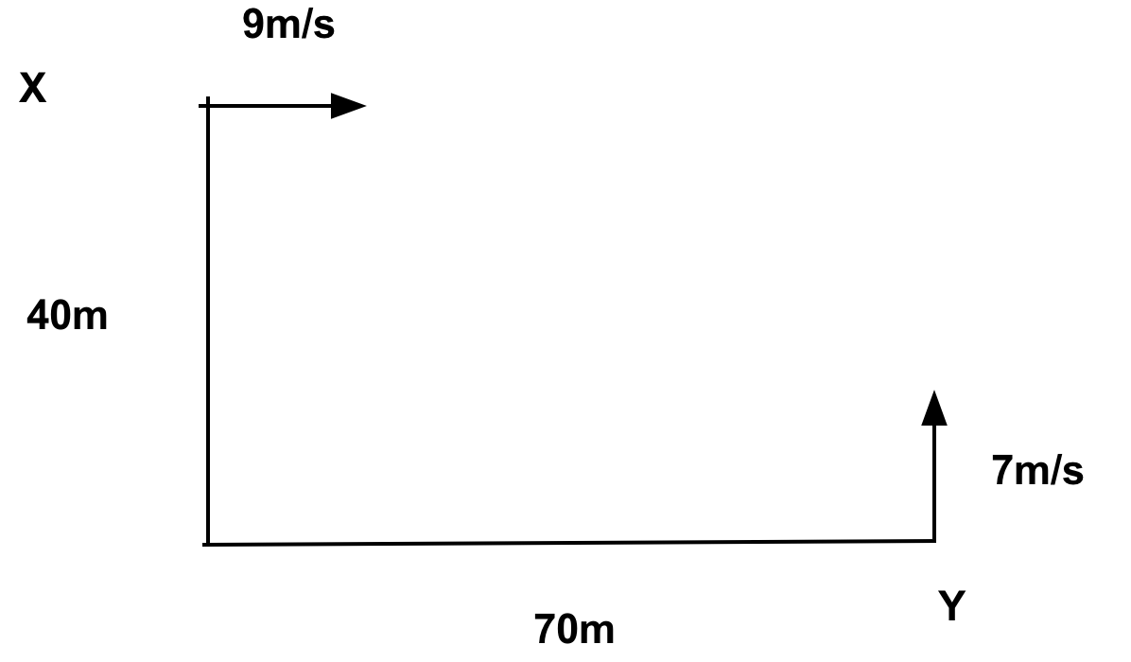√

(b) If the distance between the cyclist t seconds later is D metres, show that
D² = 6500 −1820t + 130t² (3 marks)
D² = (70 − 9t)² + (40 −7t)² √ √
= 4900 − 1260t + 81t² + 1600 − 560t + 49t² √
= 6500 −1820t + 130t²

(c) Determine the time the cyclists are closest together and determine the minimum distance between them.

at t = 7 sec √ the minimum distance is 130 metres. √ (2 marks)

Question 19 (5 marks)
The cross section of land can be modeled by the equation

H = 0.00003d(d − 30)(d − 50)(100 − d) where H and d are, respectively, the height (in metres) above a fixed horizontal level and the distance (in metres) from a fixed point.

The cross section has been shown in the diagram below.

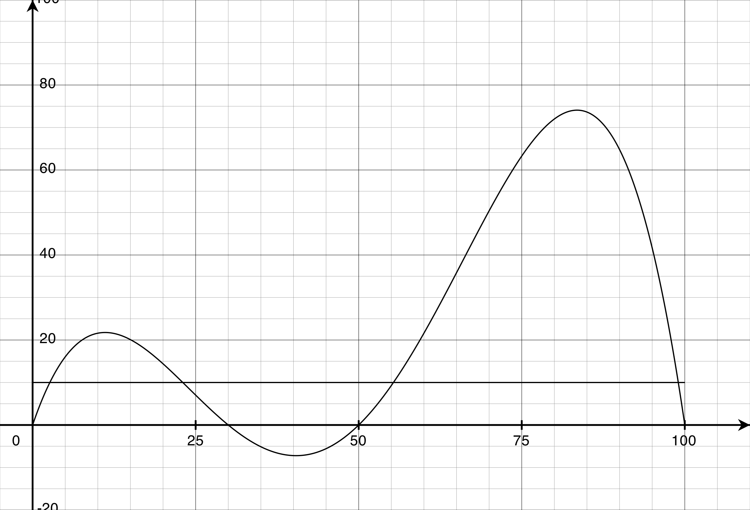

A tunnel, 10m high, will be constructed through the two hills. Show how the cross sectional area of soil removed can be determined using integrals and mensuration (measurement) formula. There is
no need to evaluate your answer. (5 marks)
x intercepts at 30 m, 50 m and 100 m √

Solve for 0.00003d(d − 30)(d − 50)(100 − d) = 10
d ≈ 2.64, 23.03, 55.33, 99.00 √ √

Area = 
 

